Buying a New Car?

You may want to read this first!

You may be out there looking for a new car and there may be something that you’re overlooking for this new purchase. You should be thinking, “Will someone want to steal my car”? According to recent data you may be safe if you’re staying away from Kias or Hyundai. Let’s look at why this is the case.

Data Source: Car Thefts Map

The rate at which cars are being stolen is on the rise. Between 2020 and 2021 there was a modest rate increase. However, in 2022 the rate increase appears to be the same as the previous two years combined. Based on this alone, the thought of “will someone steal my car” Should be brought up prior to any new or used vehicle purchase. However, there are two brands for which the rate of theft is increasing significantly.

Data Source: Motherboard VICE News Kia Hyundai Theft Data

Overall, Kia and Hyundai thefts have been increasing in the United States at least since 2019 as shown. There seems to be a constant increase since 2021. This would lead one to assume that the total thefts of these brands would be even higher in 2024. Although the United States is large, and these thefts could be happening anywhere. Let’s look at a few states where reports available.

Data Source: Kia Hyundai Thefts

Aside from a few states, the total number of car thefts that are either a Kia or Hyundai appear to be about the same. According to the Kia/Hyundai theft data frame, Illinois is leading in the total number of thefts for these car brands. Ohio appears to come in second followed by Maryland and Oregon. The state that has the least amount of Kia/Hyundai thefts appears to be Washington DC. However, this is a small area to consider. It may be better to view these thefts by year.

Data source: Kia Hyundai Thefts

As seen from the area plot of the Honda and kia thefts, we see the large spike in thefts in 2022. Between 2019 and 2021 there seem to be only a few states reporting the theft of Kia or Hyundai. 2022 is when multiple states were reporting these thefts. However, the states of Illinois, Maryland, Ohio, and Washington were always reporting these thefts. Aside from Washington, the other three increased enough in 2022 to help contribute to the spike of thefts reported.

For the time being you may think that your safe to by a Kia or a Hyundai if you don’t live in one the states that were represented. However, with the car thefts increasing as they are, it’s only a matter of time until more states start reporting higher numbers of thefts of these car brands. I feel comfortable saying this due to the correlation between thefts and these car brands.

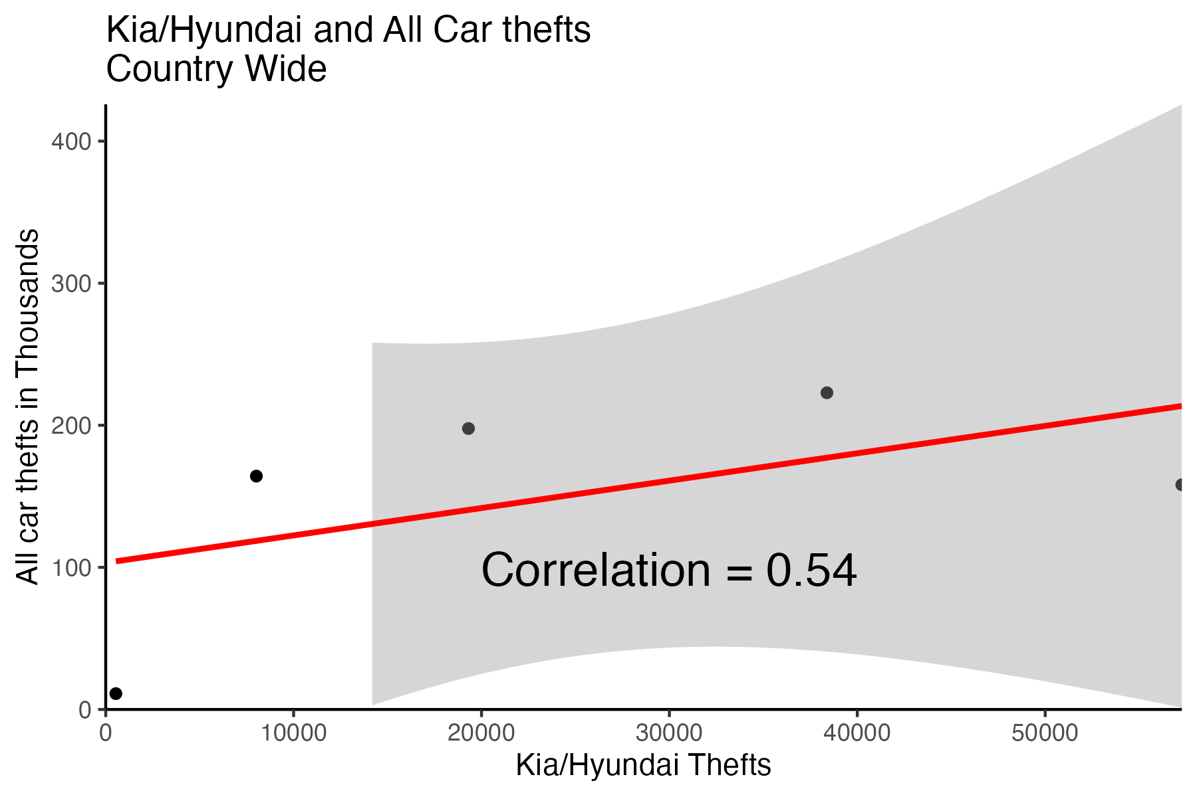

Data Source: Motherboard VICE News Kia Hyundai Theft Data

It makes sense that Kia and Hyundai thefts are related to the total number of thefts. However, consider the correlation between these two. The correlation of 0.54 is a moderate positive correlation. This would mean that there’s a noticeable relationship between these two. Even though the correlation is moderate when we consider other car brands that can be stolen, the thefts of these two car brands have a significant impact on overall car thefts. If this weren’t the case, the line of best fit would be flatter which would mean that some other or a combination of other car brands are impacting theft rates.

I do have an important warning to those of you that live in Milwaukee… please do not buy a Kia or a Hyundai. These make up almost 50% of the population of stolen cars. You may be better off choosing a different brand for your next car.

Data Source: Kia Hyundai Milwaukee Data

All in all, car thefts are on the rise, appear to be still rising and have had large spikes in the past few years. If you live in Illinois, Maryland, and Ohio you may want to reconsider your options if you want to buy a Kia or Hyundai. These three states specifically had a significant increase in these thefts in 2022. These two car brands have a moderate correlation with car thefts, but overall, this appears to be significant when considering all the other brands that are out there. Lastly, if you live in Milwaukee, you should definitely not have one of these brands as your next purchase. You need to stay away from them... unless you’re wanting your car stolen.